SMARTSDLC-AI-ENCHANCED SOFTWARE DEVELOPMENT LIFESTYLE

PROJECT DOCUMENTATION

## 

# TITLE: SMARTSDLC-AI-ENCHANCED SOFTWARE DEVELOPMENT LIFESTYLE

### 

Submitted by:

* Team Member : Anand Krishnan M G
* Team Member : Akash T
* Team Member : Rengeswaran S
* Team Member : Vinoth S
* Team Member : Mohamed Thowfik

# ACKNOWLEDGEMENT

I would like to express my sincere gratitude to the Nan Mudhalvan program for providing me the opportunity to learn and implement this project. This program has helped me gain valuable knowledge in Artificial Intelligence, Python programming, and practical application development. I also thank my faculty members and peers for their guidance.

# ABSTRACT

This project, titled 'Health AI – AI Code Analysis & Generator', is developed as part of the Nan Mudhalvan program. The objective of this project is to provide a user-friendly AI-based system that can analyze software requirements from text or PDF documents and automatically generate well-structured code in multiple programming languages. The project leverages modern AI models, Gradio interface for deployment, and Python libraries for handling data. This project demonstrates the integration of requirement engineering with automated code generation.

# INTRODUCTION

Artificial Intelligence (AI) is playing a significant role in modern software development. Requirement gathering and code generation are two of the most time-consuming aspects of software engineering. The aim of this project is to simplify these tasks using AI models. The Health AI project provides an interface where users can upload requirement documents or manually enter them, and the system analyzes and organizes the requirements. In addition, it allows automatic code generation in various programming languages based on the provided requirements.

# SYSTEM REQUIREMENTS

The system requirements for developing and running this project are as follows:

• Hardware: Laptop/PC with minimum 4GB RAM, Intel i3 or above processor

• Software: Python 3.10+, Google Colab / Jupyter Notebook, Gradio, Transformers, Torch, PyPDF2

# MODULES IMPLEMENTED

1. Requirement Analysis Module – Extracts text from PDF or user input and classifies requirements.

2. Code Generation Module – Generates code in Python, Java, C++, and other languages using AI.

# IMPLEMENTATION

The project is implemented in Python using the following major libraries:

• Gradio – For creating interactive user interfaces

• Transformers – For using AI models (IBM Granite)

• Torch – For handling computations on CPU/GPU

• PyPDF2 – For extracting text from PDF documents

The system consists of two main tabs: Code Analysis and Code Generation. In Code Analysis, the user can upload a PDF or enter requirements, which are then analyzed by the AI model. In Code Generation, the user can input requirements and select a programming language to generate the respective code.

# OUTPUT

The output of the project is presented through a Gradio interface with two tabs:  
• Requirements Analysis – Displays functional, non-functional, and technical requirements extracted from input.  
• Code Generation – Displays auto-generated code based on user requirements and chosen programming language.  
  
Screenshots of the interface and outputs can be inserted here.

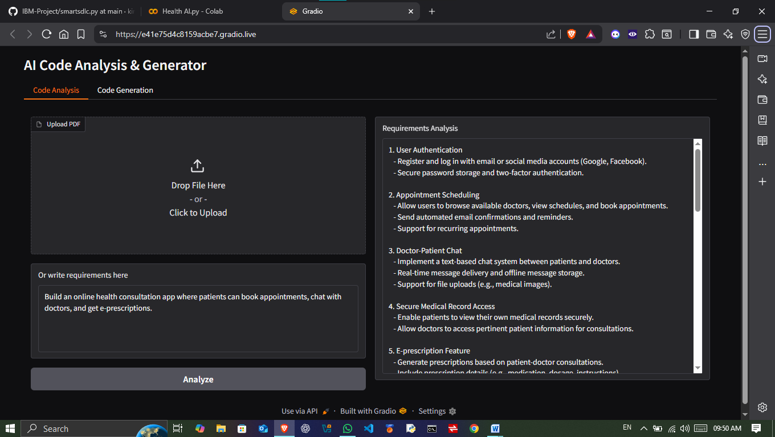

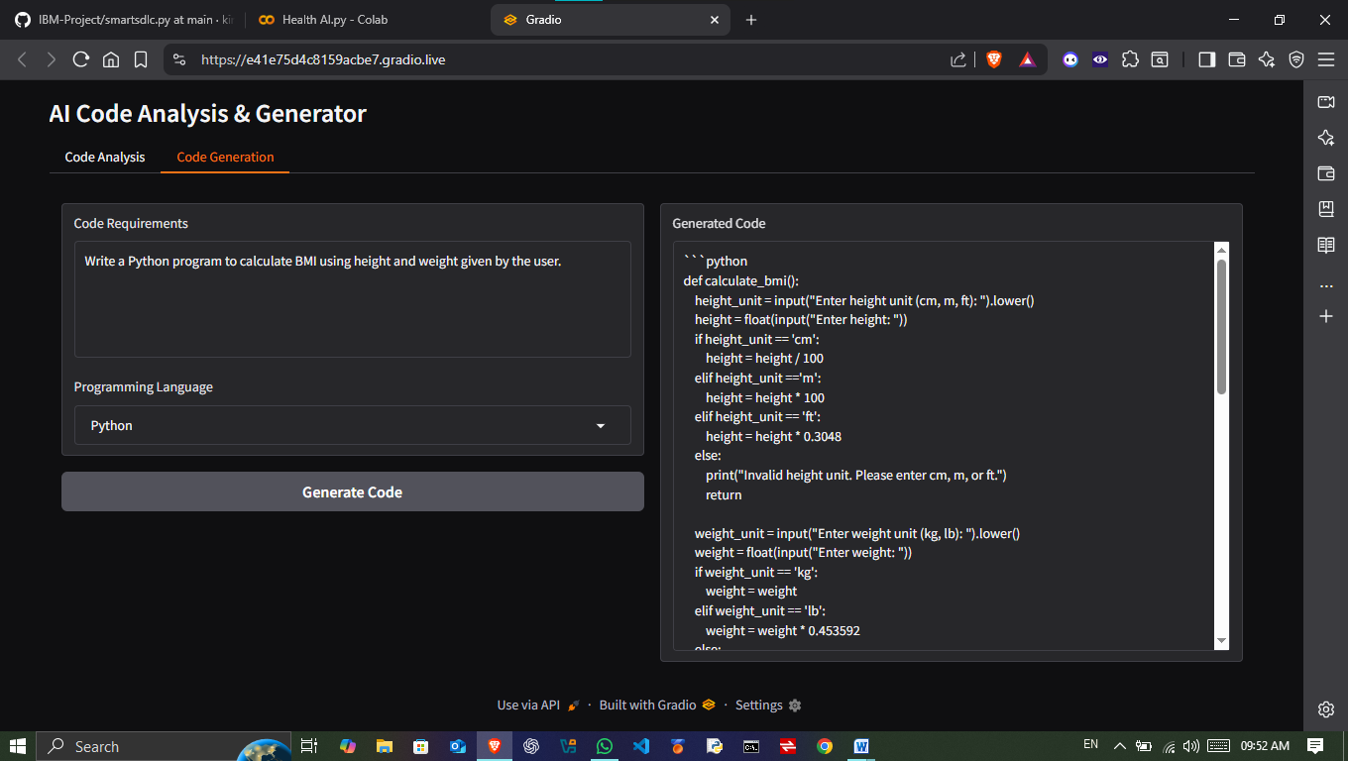

# CONCLUSION

The Health AI project successfully demonstrates the potential of Artificial Intelligence in software engineering. It provides an efficient solution for analyzing requirements and generating code automatically. Through this project, I have learned the integration of AI models with practical applications, handling of text data, and building interactive interfaces with Gradio. In the future, this project can be extended to support advanced requirement engineering, domain-specific code templates, and real-time collaboration features.

# REFERENCES

1. IBM Granite Model Documentation

2. Hugging Face Transformers Library

3. Gradio Documentation

4. PyTorch Documentation

5. PyPDF2 Library